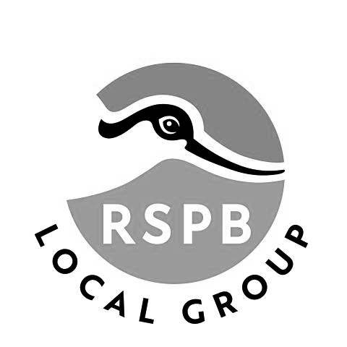
Lincoln RSPB Local Group
Holiday Booking Form

The Lancashire Hotpot

29th-31st October 2026

Our Autumn holiday to Lancashire
In association with Cairngorm Travel

Visit Brockholes Nature Reserve on the way to Lancashire
Explore RSPB Leighton Moss, one of the RSPB’s “Flagship” reserves

£300 per person in a twin, double or single room
Deposit £50 Balance Payable by 31st July 2026

Includes coach transport from and to Lincoln and between the hotel and the reserves, two nights dinner, bed and breakfast
at the Best Western Lothersdale Hotel, Morecambe, and driver’s gratuity.

Name(s):___________________________________________________________

Address: ___________________________________________________________

Email:___________________________Phone_____________________________

Room required: Double / Twin / Single

Dietary requirements: gluten-free / lactose-free / nut allergy / other __________

Emergency contact name, phone number and relationship

Complete the booking form and email to holidays@lincolnrspb.org.uk

PAYMENT
By BACS (preferred)

Account Name : RSPB Lincoln Holidays Account Type : Business Account
Account Nr. : 36613960 Sort Code : 30-96-26
Reference : Lancashire

Or by Cheque

Send your cheque and booking form to:
Graham Mumby-Croft, 15 Thirsk Drive, Lincoln LN6 8SZ

Please make sure you read the “small print” overleaf!

PICKUP POINT

Please indicate your preferred pickup point:

Hykeham Station ____________ Lidl, Newark Road ______________
Lincoln Station ______________ Other ________________________
Parking is available at Hykeham Station in the first section of the car park, NOT in the fenced car park next to the station itself.

The “small print”:

INSURANCE
Under law (as overseen by The Charity Commission) any activity run by a Charitable Group for the benefit of its members which involves any overnight hotel accommodation is deemed to be a “social event” and does not count as a “charitable activity”. Consequently neither the RSPB nor Lincoln RSPB Local Group provide any form of insurance or indemnity to cover personal injury or cancellation of your booking by you, or any unforeseen circumstances during the trip. As we use a reputable coach company for our travel you are covered under their insurance for the periods whilst you are “in transit” and under the care of their driver. We do however carry Public Liability insurance that covers Group members against 3rd party claims for damage that may be caused either by the Group, or an individual member.
You are therefore strongly recommended to make sure that you have suitable travel insurance that provides you with personal injury and cancellation cover.

REFUND POLICY
Deposits are non-refundable unless your place is re-sold or the event is cancelled, in which case a full refund will be made. Once the balance has been paid, refunds can only be made if the hotel makes a refund or we are able to book a replacement participant.

CANCELLATION BY LINCOLN RSPB
In the event that there are insufficient bookings to cover the costs of the holiday by the date on which the balance of the holiday price is due, Lincoln RSPB Local Group reserves the right to cancel the holiday and refund all monies paid.

PROCEEDS
In booking this holiday you accept and agree to Lincoln RSPB Local Group utilising any proceeds remaining after payment of all costs and charges for supporting its activities and projects or for donation to the RSPB.

EMERGENCY CONTACT
In providing details of your Emergency Contact you authorise the trip leaders to use that contact during the trip should they consider it necessary.

DATA PROTECTION
Your data will be held by Lincoln RSPB Local Group until the trip has been completed. It will be not be used for any other purpose except for contacting you about or during this trip.

Lincoln RSPB Local Group is arranging this holiday as an occasional offering to a limited group of travellers. It cannot be construed as a Package Holiday within the terms of the Package Travel and Linked Arrangements Regulations 2018.

